Smart Glasses via Audio

# 视觉增强眼镜

|  |  |  |
| --- | --- | --- |
| https://imgslim.geekpark.net/uploads/image/file/ce/02/ce024d9707019e0c1dd036f01c6f4c01.jpg | https://img-prod-cms-rt-microsoft-com.akamaized.net/cms/api/am/imageFileData/RWtpXS?ver=fa1f&q=90&m=6&h=1080&w=1920&b=%23FFFFFFFF&l=f&o=t&x=937&y=656 | https://imgslim.geekpark.net/uploads/image/file/7f/71/7f714edbf008eb36fdf7ff3aab803548.jpg |
| Google Glasses | Microsoft HoloLens | SnapChat Spectacles |

# 骨传导太阳镜

|  |  |
| --- | --- |
| Image result for AfterShokz OptiShokz |  |
| OptiShokz REVVEZ (Aftershokz) | VUE glasses |

## 骨传导技术概念

|  |  |  |
| --- | --- | --- |
| Image result for AfterShokz OptiShokz |  |  |

# 定向扬声器眼镜

|  |  |  |  |
| --- | --- | --- | --- |
| https://images-na.ssl-images-amazon.com/images/I/61CebdzaKEL._AC_SX569_.jpg | https://consumer-img.huawei.com/content/dam/huawei-cbg-site/common/mkt/pdp/accessories/gentle-monster-eyewear/imgs/perrier_pckv.jpg | https://www.bose.cn/content/dam/Bose_DAM/Web/consumer_electronics/global/products/wearables/bose_frames_rondo/images/alto_product_page_modern_boy_in_jacket_classic_whitespace_2x1.psd/jcr:content/renditions/cq5dam.web.1280.1280.jpeg |  |
| Echo Frames | 华为 Eyewear | Bose Frames | Mutrics |
| 2019/9 | 2019/3 | 2018 / 3 | 2019 CES |
| 平镜/光学眼镜  支持Alexa | 联合Gentle Monster  触控交互  支持华为小艺  支持Siri和Google Assistant | 太阳镜  蓝牙耳机  语音 AR(地理位置服务)  支持Siri和Google Assistant | 双微型扬声器  近场环绕立体声效果  Google Translation等应用  支持Siri和Google Assistant |

## 声学结构和示意图

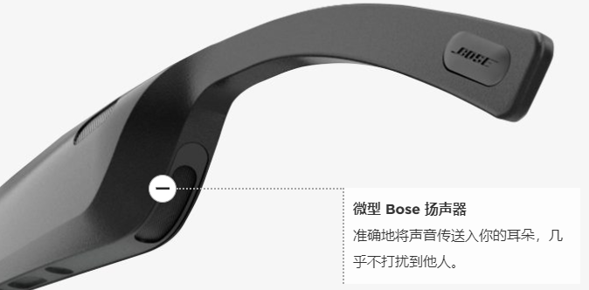

|  |  |  |
| --- | --- | --- |
| 横比华为 Eyewear、Bose Frames 和 Mutrics，看智能眼镜的当下与未来 | 横比华为 Eyewear、Bose Frames 和 Mutrics，看智能眼镜的当下与未来 | 横比华为 Eyewear、Bose Frames 和 Mutrics，看智能眼镜的当下与未来 |
|  | 横比华为 Eyewear、Bose Frames 和 Mutrics，看智能眼镜的当下与未来 |  |
| 华为 Eyewear | Bose Frames | Mutrics |